

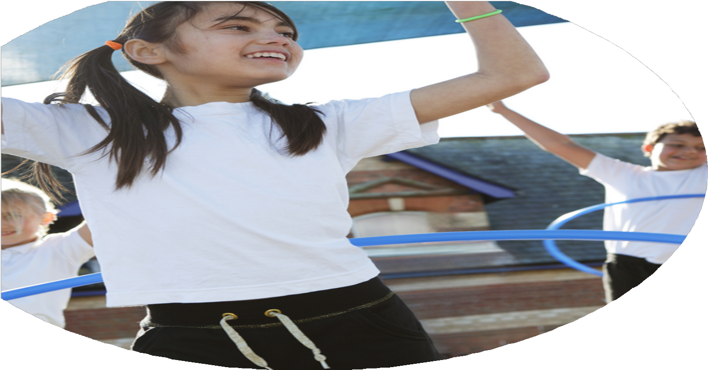
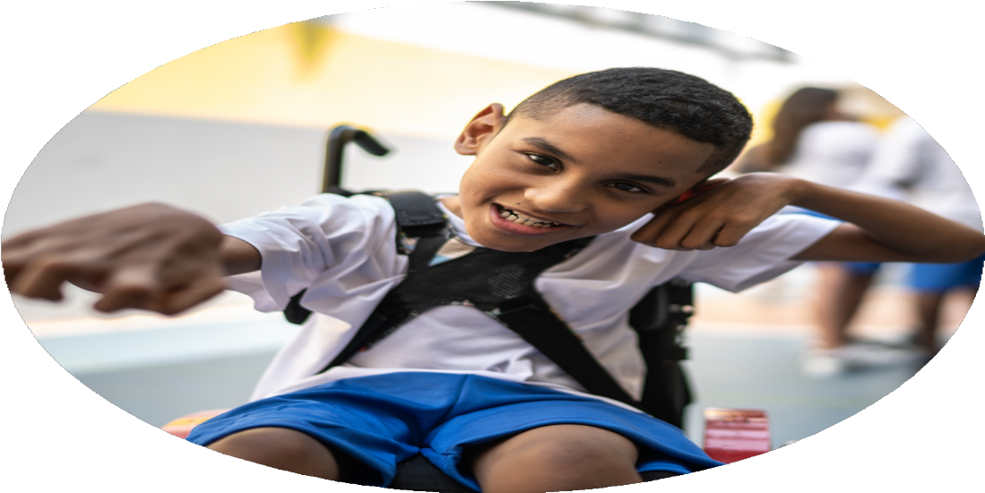




PE Funding

Evaluation Form

Commissioned by

Created by

Images courtesy of Youth Sport Trust

PE Funding Evaluation Form

It is intended that this template should be used as preparation for the completion of the statutory digital reporting tool being introduced this academic year. You can upload data (including swimming) from this template onto this platform once it becomes accessible.
Before you decide how you are going to use the funding for this academic year you should reflect and evaluate the impact of your use of the funding in 2023/24.
All spending of the funding must conform with the terms outlined in the Conditions of Grant document. The template is a working document that you can amend/update during the year.
Based on your evaluation of last year’s funding you should decide what you intend to do this academic year, how you will do it, and what impact you expect it to have.

It is important that the funding is used effectively and based on your school’s needs.
You must use the funding to make additional and sustainable improvements to the PE and sport in your school. You must develop and add to the PESSPA activities that your school already offers.

Summative digital reporting from June 2025 will continue to include swimming and water safety information therefore funding can be used to provide top-up lessons where necessary to ensure pupils meet national curriculum swimming requirements.

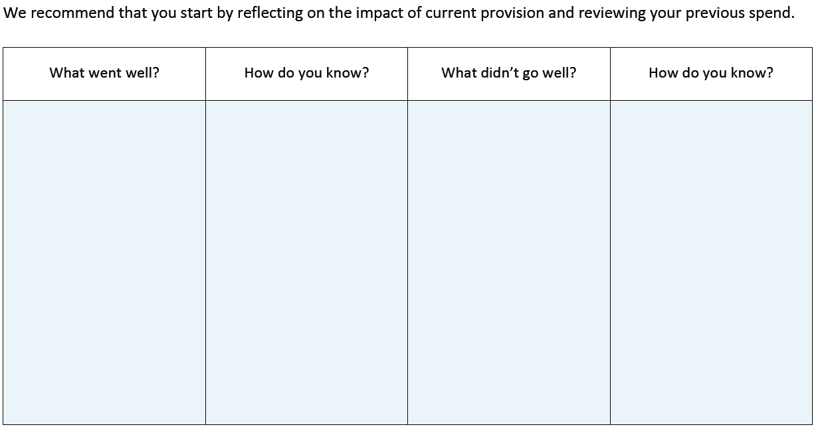
Feedback from staff.

Not enough competitions on offer to facilitate KS1 and EYFS.
Ensuring all staff received the same amount of support from external coach throughout the year.

Buy into Havant & Waterlooville School Games.

Teaching staff- All to be confident in the delivery of PE and ensure all children achieve.
All Pupils to have access to high quality PE teaching.

Beach School highlighted as a strength in the school’s OFSTED.

External coach brought in for CPD training to upskill current teaching staff and to support ECT’s

To continue to deliver Beach School sessions to all.

What are your plans for 2024/25?

Intent
How are you going to action and achieve these plans?

Implementation
- Hiring a fully qualified swimming coach to deliver high quality swimming lessons to all children.
- Use of external coach to team teach alongside class teacher to support upskilling.
- Training 2 new members of staff on the delivery of Beach Schools and the impact in can have on children’s wellbeing. – Hiring of minibus to help facilitate travel to the beach.
- Ensure all EYFS children are competent on a scooter and know how to travel on them safely to help boost a different way of travelling to school.
- Coach to work alongside MDSA to help deliver a wide range of physical activities children can take part in to boost engagement and physical activity during lunchtimes.
- Training delivered to staff on how to access new curriculum to support broadening children’s experiences to competitive sports. Research was undertaken to find a suitable curriculum that ensured teachers were given the knowledge and support on how to deliver high quality PE sessions.
- To ensure all children have the opportunity to participate in at least half a terms worth of swimming lessons. £1750
- Continue to support and develop teaching staff’s particularly ECT’s confidence in delivering high quality PE sessions. £1050 £1000 Resources
- To continue to run Beach school sessions for the children. £8000 (training) £500 minibus hire
- Scooter training for EYFS £300
- External coach to support and upskill MDSA once a week with activities and games. £1050 Coach £500 resources
- Purchasing a new curriculum for PE and getting resources to support implementation. £257 £1500 Resources

What impact/intended impact/sustainability are you
expecting?
How will you know? What evidence do you have or
expect to have?
- Progression in swimming lessons and feedback from swimming coach on the progress children are making. – Discussions with children on water safety and addressing any misconceptions.
- Observations from lessons to see children’s learning is being extended and developed appropriately.- discussions with staff on the support given during team teaching and how further we can develop this.
- Feedback from children and parents on discussing their beach school sessions
- Will see an uptake in more Year R children choosing to travel to school using their scooter.- will see more careful use of school scooters and how to keep ourselves and others safe.
- Children to be observed being more active, less experience children will be targeted to take part in activities and tailoring support to ensure all can achieve and participate.
- Children will be aware of how to keep safe when in water learning necessary life skill.- To continue to further develop those who have already had lessons and to start with those joining school as beneficial for our children with living so close to the sea.
- Staff will be more skilled in delivering high quality PE sessions, knowing how to support and extend children’s learning. ECT’s in particular will have a good solid understanding of the need for high quality PE sessions and how to deliver these.
- Weekly beach schools sessions will help promote a healthy lifestyle with being physically active without having to be part of a PE session- digging the sand, picking up and carrying stones ect.
- Children will engage with training and utilize this to support how they travel to school- accessing more physical activity.
- Children will be more active during lunchtimes and staff are able to support children for rest of the week with exciting games and activities.

What impact/sustainability have you seen?
What evidence do you have?

