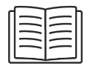  Literacy  This half term we will begin with exploring listening activities during our phonics sessions. We will move onto beginning to learn the start of Phase 2; s a t p i n m d g o c k ck e u r. The children will get to know how to pronounce the sound, find it within words and how to write each letter correctly. |   Maths  This half term the children will be exploring how to match, sort and compare objects, moving onto talking about measurement and patterns followed up by exploring numbers 1-3. | 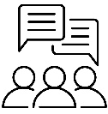  Communication and language  This half term the children will Enjoy listening to simple stories and starting to retell them, we will also be working on understanding  a question or instruction that has two parts, such as: “Get your water bottle and line up”.
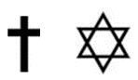    Religious Education  This half term we will be exploring ‘all about me’. The children will learn what makes them ‘them’ and then move onto what makes someone a ‘Christian’. |   Personal, Social and Emotional Development  This half term the children will be learning the rules and boundaries of the school and how they need to behave in order to keep themselves and others safe. We will also be exploring friendships and how to be a good friend. |   Music  This half term the children will Joining in with class actions  Perform actions in time to the music  Remember and sing the words to the songs  Sing in time using the correct pitch  Remember the names of a basic selection of instruments e.g. claves, wood blocks, shaky eggs, triangles, sleigh bells and drums.
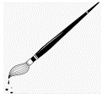    Expressive Arts and Design  This is half term the children will learn about how to explore different materials and develop their ideas about how to use them and what to make with a focus on colours and texture. | Physical Development  This half term we will be exploring different ways we can move our bodies for a purpose. We will be using the theme from Real PE of ‘Going on a bike ride’ to help us think and create our different movements. | 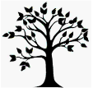      Understanding the World  This half term we will be exploring the natural world around us, looking at clues for knowing the seasons are changing and what this means.
Key dates for this half term
16th Sep - Open Classrooms- Come and have a look around!
22nd - oct flu immunisation – Parental permission required.
22nd Oct Parents evening
23rd Oct Parents evening
25th Oct Inset Day

Useful learning links
- Numbots (login will be sent home)
- Bugclub (login will be sent home)
- Oxford owl
- Ict games
- Bbc iplayer – numberblocks, alphablocks,
- Cosmic yoga (youtube)
- Top Marks Maths games

