Prospectus 2025-26

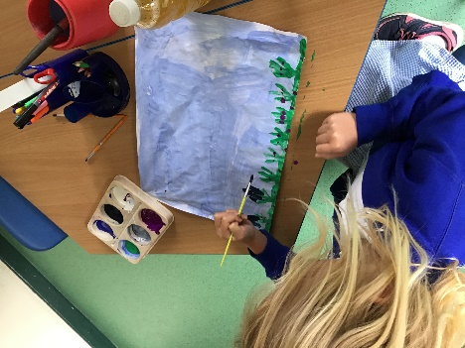

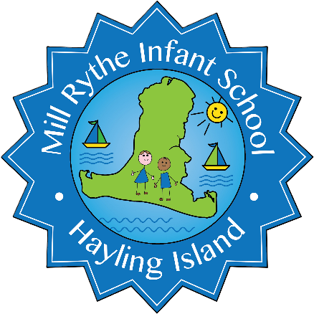
Nurture Inspire Challenge
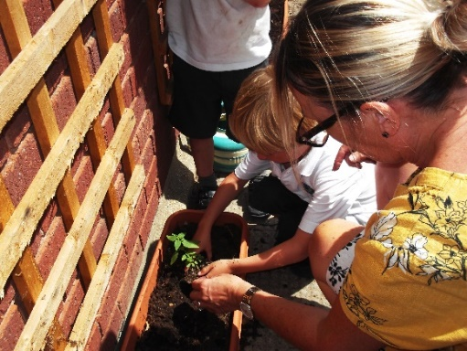
Welcome to Mill Rythe Infants!
We are delighted to welcome you and your little one to our school. Choosing the right first school is an important decision, and we’re thrilled that you are considering Mill Rythe Infant School for your child.
This prospectus gives you a glimpse of our happy, caring school community. Our school was rated ‘Good’ by Ofsted in February 2023 and is conveniently just 10 minutes from the centre of Havant. Our friendly staff and children are always happy to answer any questions you may have.
At Mill Rythe Infant School, we love helping children learn, explore, and grow. We encourage curiosity, creativity, and confidence so that every child can discover the joy of learning from the very first day. We hope you enjoy your visit and that we can answer all your questions about starting school.
We look forward to welcoming you and your family and supporting you as your child begins their exciting journey at school.

Mrs Lucy Ford.

About us
Welcome to our school! We are a two-form entry Infant School situated in the heart of Hayling Island. We accept children between 4 and 7 years of age. Our classrooms are bright and engaging spaces in which children are nurtured and supported to thrive. We are fortunate to have spacious grounds which include a sensory garden, adventure playground, trim trail and both wooded and grassy areas. Our children love to explore the outdoors in all weathers so pack some wellies!
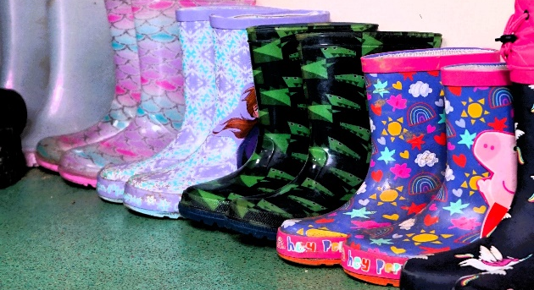
Our values are ‘Nurture, Inspire, Challenge’ and they sit at the heart of everything we do. When choosing this school you are choosing exciting opportunities for your child to explore new experiences such as swimming, beach school and woodworking. Your child will be cared for and supported by every member of our team, working with you to enable your child to achieve their dreams.

We want our classrooms to be full of happy, engaged children who love learning. That’s why our pupils all have access to age-appropriate resources, a stimulating curriculum and warm, responsive staff. We are fortunate to have classrooms filled with natural light and a new, purpose-built woodland library.
What are our learning spaces like?
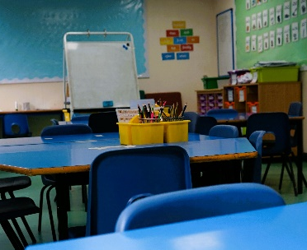

Our Early Years space is bright and engaging, perfect for free-flow learning to support transition from nursery. Your child will have the opportunity to lead their play, supplemented by carefully planned activities and questioning from our skilled staff. Phonics, Writing and Maths are taught daily, with all children receiving timely feedback to boost their confidence and mastery of the EYFS curriculum.

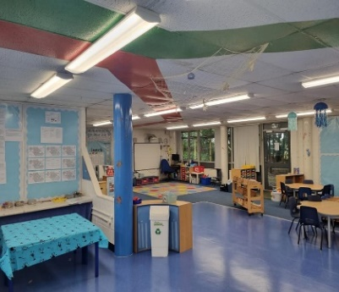

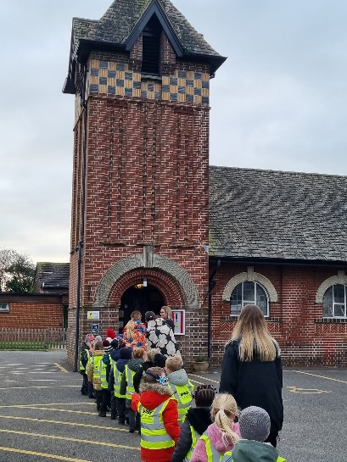
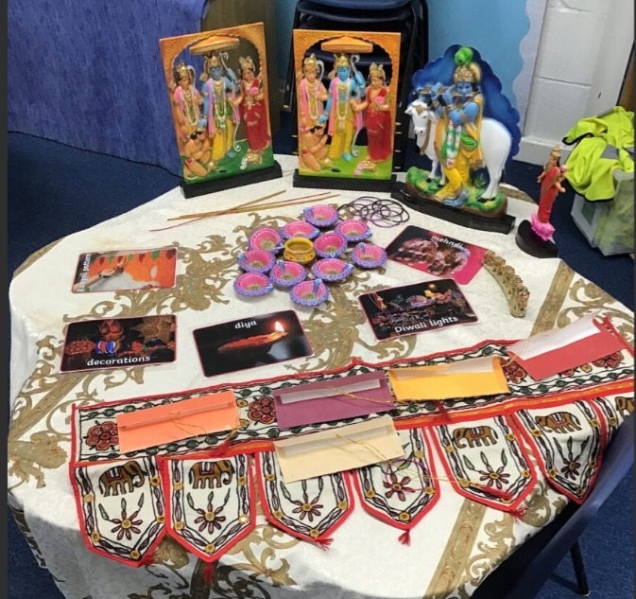
Our Year 1 wing is at the North of the school with the Year 2 wing to the South. Both year groups have a large, open shared area for small group work and open-plan classrooms. Each Key Stage 1 classroom has a set of toilets and cloakroom area. Core subjects such as Maths, Writing and Phonics are taught in the morning, with the afternoons dedicated to sports, Creative Arts, Science and Humanities. Our Religious Education curriculum is Living Difference, the agreed syllabus for Hampshire.

We are a non-denominational school and share information and beliefs from all major faiths throughout the school year within our weekly RE assemblies. Our Religious Education lessons focus on Christianity and Hinduism. For further information about how we teach about religion and culture please ask.

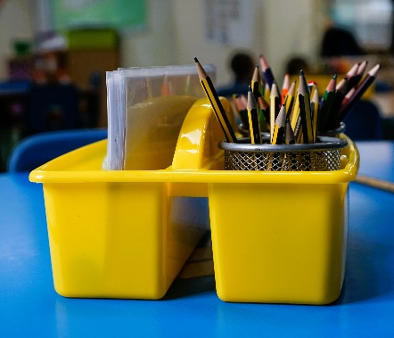
Every morning you and your child will be welcomed to the playground by a member of staff before proceeding to your classroom. Teaching and support staff are always present to greet your child at the classroom door, welcome them into the building and support them with putting away their belongings.
What do we do at school?
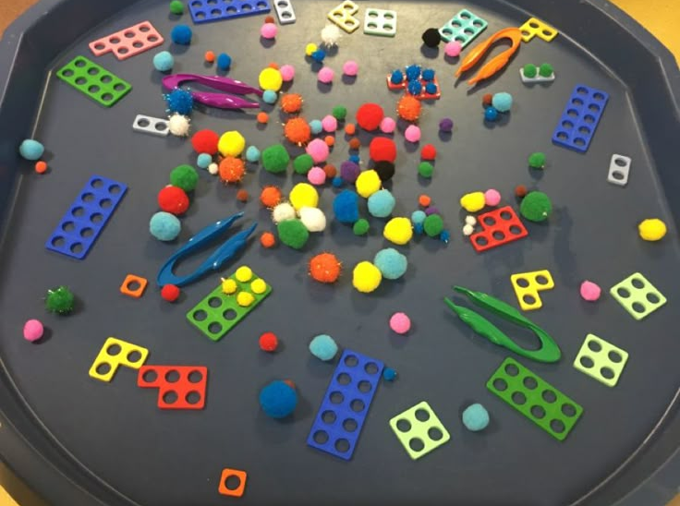
In Reading and Phonics your child will be encouraged to sound out words, blend them together and build their understanding of new vocabulary. In Maths and Writing children are provided with tailored learning and supported to apply what they have learned. We have well-resourced classrooms for all subjects and encourage pupils to build familiarity with sound mats, counting objects and number lines to secure their understanding.
Each child is allocated a special ‘Morning Job’ to start off their day and warm up their brains! Morning Jobs are a popular feature of our daily routine and support the children in strengthening fine motor skills (EYFS) and practising key skills like handwriting and counting.
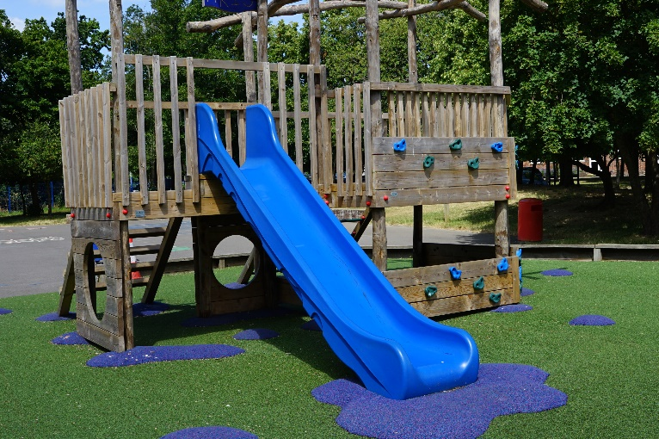
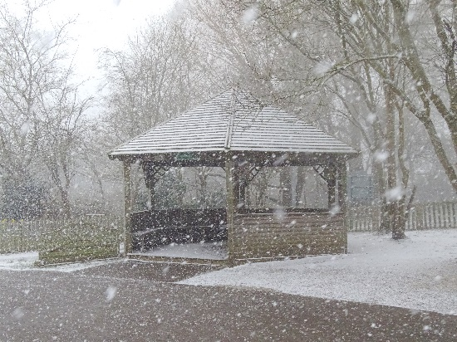
Lunchtimes and playtimes are an important part of our day for developing friendships, speaking and listening skills and creating shared games. Our children have access to a wide range of play equipment and lunchtime supervisors to scaffold playtime and ensure all children have the opportunity to join in. We are outdoors in all weathers and our wooded area, grassy banks and playground area means all children have the opportunity to explore the world around them.
We love watching the changing seasons and encourage all children to bring in wellingtons to keep at school so they can explore the muddy puddles and – if we are very lucky – snow!
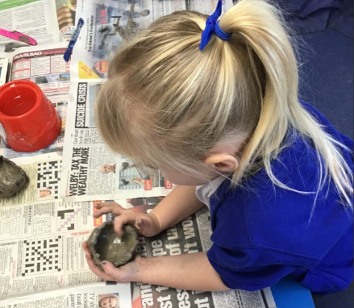
Our foundation subjects are a wonderful celebration of creativity! From Sports to Arts to History, we encourage a love and understanding of the world around us. Our foundation subjects have a carefully sequenced curriculum to ensure all our children develop a strong understanding of each subject. The children love nothing more than getting out the musical instruments or preparing and cutting up different foods to share!

Assembly is at the end of the day and is a calm time to come together as a school to reflect. Through assemblies we cover topics such as online safety, world religions and community celebrations, plus our ever popular singing assemblies. Our year groups invite parents into assemblies and performances over the course of the year. It is magical to watch the Early Years Nativity at Christmas and see how much our older children have grown by their final performance in the Summer term of Year 2.
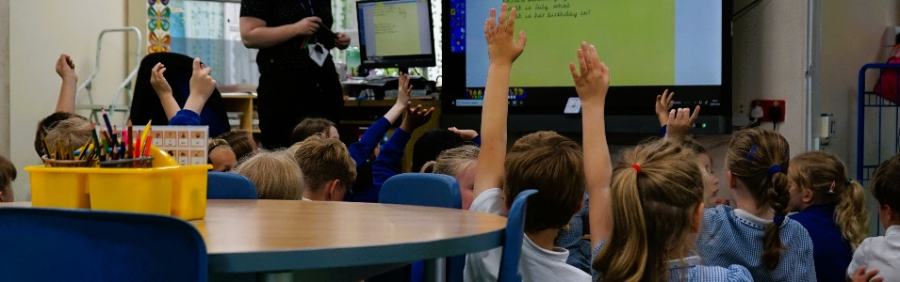
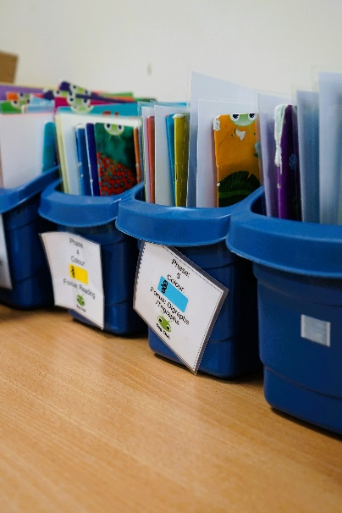
We understand how hard it can be to fit home learning in around busy family life. That’s why we aim to keep it as simple as possible: read together once a day and up to 10 minutes of Maths practise a week. All children will bring home a book linked to their Phonic ability, a library book and logins to our online reading library and online Maths practise. As a reward for completing their Reading children can earn a series of jewel badges, while Maths practise is rewarded with certificates in assembly.

If you need childcare before or after school, we have a variety of clubs to suit the needs of your family. Just see our Frequently Asked Questions or website for a timetable of when each club is available.
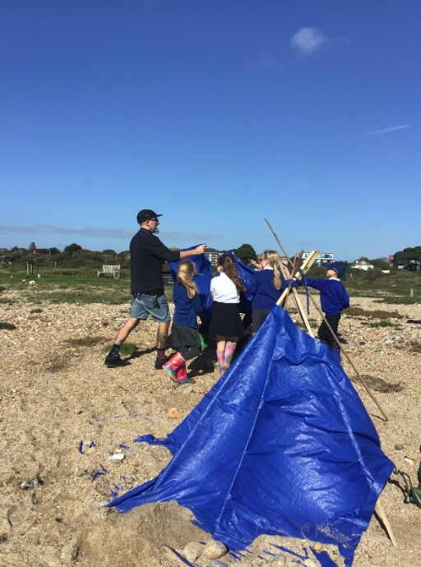

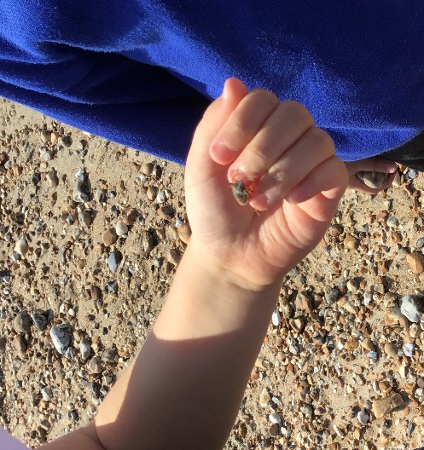

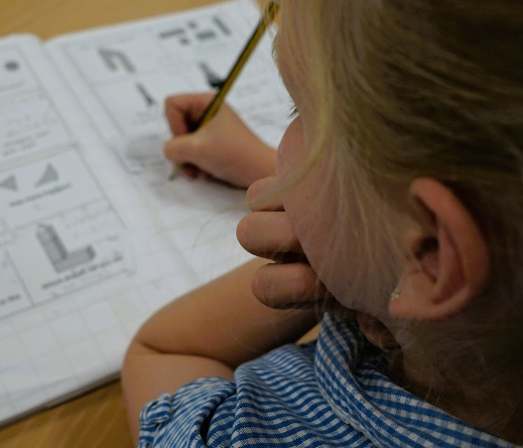

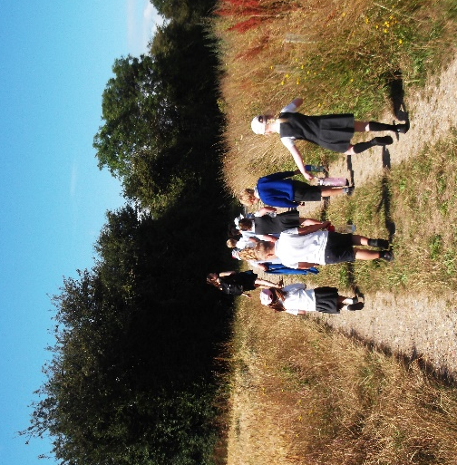
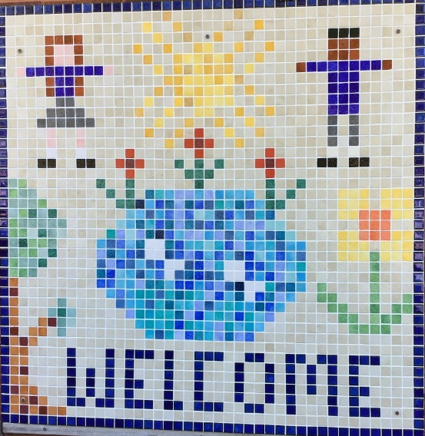
Thank you so much for taking the time to visit Mill Rythe Infant School. We hope you enjoyed seeing our welcoming classrooms, and dedicated staff in action. If you would like to have an additional visit before making a decision about applying, please just contact our office.
We believe our school offers a nurturing, inspiring environment where every child can thrive, and we would be delighted to welcome your family to join our community. If you feel Mill Rythe Infant School is the right place for your child, we encourage you to apply and become part of our exciting journey in learning and discovery!

adminoffice@millrythe-inf.hants.sch.uk
www.millrytheinfants.co.uk
02392 465 531

